We’re The International Authorized Training and Exam Center for the following Exam Sponsors and Delivery Partners:

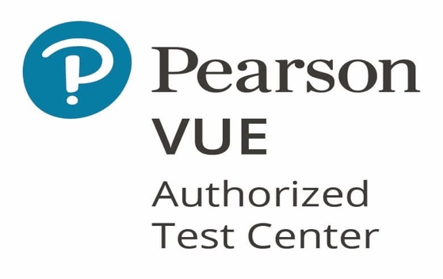

We Now have Client Authorization from Pearson to deliver exams for the following Pearson VUE clients: **(By Company)**

* **ABA Espana**
* **ABWM**
* **ACSM**
* **AFP**
* **AHIMA**
* **AIWMI**
* **Alibaba Cloud Certification**
* **Amazon Web Services**
* **American Academy of Financial Management India**
* **American College**
* **American Society for Nondestructive Testing**
* **AMPP**
* **APICS**
* **Aptitude Test for Entrance Exam- ATEE**
* **Baidu Certification**
* **Basic Ability Exam**
* **BBPSD**
* **The Chartered Institute for IT**
* **BOMI International**
* **Brightest GmbH**
* **Broadcom Software**
* **Business Solutions Suite**
* **CertiTrek**
* **CertNexus**
* **Chainshine Financial Training**
* **Chartered Global Management Accountant**
* **Chartered Institute of Management Accountants**
* **Check Point Software Technologies**
* **Cisco Systems**
* **Citrix Systems**
* **CMA Sri Lanka**
* **CompTIA Testing**
* **Condition Zebra (M) Sdn. Bhd.**
* **CPS HR**
* **CrossFit**
* **CyberArk**
* **EC-Council**
* **Epic Systems Corporation**
* **Ericsson**
* **ForgeRock**
* **Fortinet**
* **GASQ**
* **GIAC**
* **GISCI**
* **Global Association of Risk Professionals**
* **Globex Certifications Inc.**
* **Guild of Architectural Ironmongers Ltd**
* **Hack2Secure**
* **HCL Software Academy**
* **HPE Certification and Learning**
* **Huawei**
* **IBM Corporation**
* **IFRS Foundation**
* **IGP&I Clubs**
* **Infosys Limited**
* **Institute of Chartered IT Professionals**
* **Institute of International Container Lessors**
* **Intel**
* **International Association for Health Coaches (IAHC)**
* **International Association of Privacy Professionals**
* **JMA Certification (CPP/CPE/CPF)**
* **Juniper Networks**
* **Linux Professional Institute Testing**
* **London Academy of Professional Training**
* **LPI-Japan Testing**
* **Metacred**
* **Microsoft**
* **National Restaurant Association**
* **Neptune**
* **NetApp**
* **Nokia**
* **Omnissa**
* **PCI Security Standards Council**
* **Pearson VUE Orientation Exam**
* **Pegasystems Inc**
* **PMI - Project Management Institute**
* **Rocheston Press Pvt Ltd**
* **Ruijie Networks**
* **Japan Ltd**
* **Snowflake**
* **Society for Maintenance & Reliability Professionals**
* **Splunk**
* **Strasz Assessment System**
* **Tableau**
* **Teradata**
* **The QT Company**
* **U.S. Secret Service**
* **Unity Certification**
* **VEEAM VMCE**
* **VMware, LLC**
* **VUE Testing**
* **WINS**
* **ZTE**
* **ZTE Certification**

As an invaluable member of the Pearson VUE Test Center network, we’re also committed to providing required training and support for candidates or clients studying at any of our training centers or learning in a corporate environment, with video and lab training, courseware, practice test, exam vouchers etc, to ensure their success objectives are met.

|  |  |
| --- | --- |
|  | **CYBERSECURITY CAREER TRACKS** |
| * Vulnerability Assessment and Penetration Testing |
| * Network Defense and Operations |
| * Digital Forensics |
| * Application Security |
| * Incident Handling and Response |
| EC-Council had over +40 Training and Certification Programs in +145 Countries, and over +3000 Tools and Technologies. |

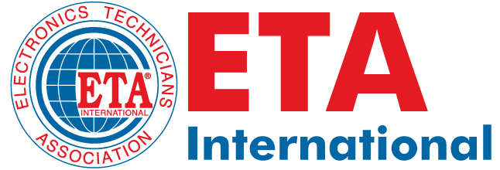

ETA® International (Electronics Technicians Association, International), founded in 1978, is a not-for-profi t, professional association promoting excellence in electronics technologies through certification.

For more than 40 years, ETA® International has represented the individual technician. While the representation has broadened over the years to include educators, business leaders, and military personnel, the mission is the same - fostering excellence in certifi cation by providing industry-accepted credentials that are accredited, technical, and vendor-neutral.

𝐄𝐋𝐄𝐂𝐓𝐑𝐎𝐍𝐈𝐂𝐒

Associate Certified Electronics Technician (CETa)

Basic Systems Technician (BST)

Electronics Modules (EM1-5)

Student Electronics Technician (SET)

𝐁𝐈𝐎𝐌𝐄𝐃𝐈𝐂𝐀𝐋

Biomedical Electronics Technician (BMD)

Biomedical Imaging Equipment Technician (BIET)

𝐂𝐎𝐌𝐌𝐔𝐍𝐈𝐂𝐀𝐓𝐈𝐎𝐍

5G Technician (5GT)

Certified Satellite Installer (CSI)

Distributed Antenna Systems (DAS)

General Communications Technician — Level 1 (GCT1)

General Communications Technician — Level 2 (GCT2)

Line & Antenna Sweep (LAS)

Microwave Radio Technician (MRT)

Mobile Communications and Electronics Installer (MCEI)

Practical Antenna Basics (PAB)

RF Interference Mitigation (RFIM)

Advanced Interference Mitigation (AIM)

Radar (RAD)

Telecommunications (TCM)

Wireless Communications (WCM)

𝐈𝐍𝐅𝐎𝐑𝐌𝐀𝐓𝐈𝐎𝐍 𝐓𝐄𝐂𝐇𝐍𝐎𝐋𝐎𝐆𝐘

Computer Service Technician (CST)

Information Technology Security (ITS)

Network Computer Technician (NCT)

Network Systems Technician (NST)

Wireless Network Technician (WNT)

𝐑𝐄𝐍𝐄𝐖𝐀𝐁𝐋𝐄 𝐄𝐍𝐄𝐑𝐆𝐘

Photovoltaic Installer — Level 1 (PVI1)

Photovoltaic Installer/Designer — Level 2 (PV2)

Small Wind Installer (SWI)

𝐒𝐌𝐀𝐑𝐓 𝐇𝐎𝐌𝐄

Certified Alarm Security Technician (CAST)

Electronic Security Networking Technician (ESNT)

Smart Technology Systems (STS)

Smart Technology Systems Master Integrator (STSmi)

𝐖𝐎𝐑𝐊𝐅𝐎𝐑𝐂𝐄 𝐑𝐄𝐀𝐃𝐈𝐍𝐄𝐒𝐒

Certified Service Manager (CSM)

Customer Service Specialist (CSS)

In addition, the U.S. military, through their individual education offices, works with ETA for both

ETA and FCC Com- mercial License testing at all U.S. military facilities worldwide

|  |  |  |
| --- | --- | --- |
|  | ASE TESTS | |
|  | AUTOMOBILE & LIGHT TRUCK TESTS | |
|  | A1 | Engine Repair |
| A2 | Automatic Transmission / Transaxle |
| A3 | Manual Drive Train and Axles |
| A4 | Suspension and Steering |
| A5 | Brakes |
| A6 | Electric and Electronic Systems |
| A7 | Heating and Air Conditioning |
| A8 | Engine Performance |
| A9 | Light Vehicle Diesel Engines |
| SERVICE CONSULTANT TEST | |
| C1 | Automobile Service Consultant |
| ALTERNATIVE FUEL TEST | |
| F1 | Compressed Natural Gas Vehicles |
| SPECIALTY TEST | |
| X1 | Exhaust Systems |

|  |  |
| --- | --- |
|  | WELDING PROCESSES |
| **SMAW Shielded Metal Arc Welding (SMAW)** |
| **GMAW Gas Metal Arc Welding (GMAW)** |
| **GMAW-S Gas Metal Arc Welding - Short Circuit** |
| **FCAW Flux Cored Arc Welding (FCAW)** |
| **GTAW Gas Tungsten Arc Welding (GTAW)** |
| **SAW Submerged Arc Welding (SAW)** |
| **BZ Brazing** |
| STANDARD FOR CERTIFIED WELDERS |

|  |  |
| --- | --- |
|  | CERTIPORT CERTIFICATIONS BY COMPANY/USE CASE |
| Adobe |
| Adobe Certified Professional in Video, Visual, Web, & Marketing Design |
| Agriscience and Technology Careers |
| Apple |
| Autodesk |
| Cisco |
| Critical Career Skills |
| Entrepreneurship and Small Business |
|  | IC3 Digital Literacy |
| We provide effective learning and practice materials as well as industry-recognized certification exams. | Information Technology Specialist |
| Intuit |
| Health Sciences Careers |
| Hospitality and Culinary Arts Careers |
| Meta |
| Microsoft |
| Pearson Languages |
| Project Management Institute (PMI) |
| Unity |

